Name : Muhammad Adeel Tariq
Trade : Cyber Security (CEH)

Practical :
Input <script>alert(1)</script> reflects back. Vulnerability name and impact?

Executive Summary
A Reflected Cross-Site Scripting (XSS) vulnerability was identified and successfully exploited on the Damn Vulnerable Web Application (DVWA) running on Metasploitable 2. The vulnerability allows an attacker to inject malicious JavaScript code that executes in the victim's browser, potentially leading to session hijacking, credential theft, and account takeover.

Vulnerability Severity: HIGH

Assessment Scope
Component | Detail
Target IP Address | 192.168.56.102
Target Application | DVWA
Security Level | High
Testing Environment | Isolated Lab Environment

Step-by-Step Testing Procedure:
Step 1: Target Identification
The first step was to identify the IP address of the Metasploitable 2 virtual machine. The ifconfig command was executed on the target system, revealing the IP address 192.168.56.102. This confirmed the target was running and accessible on the network.
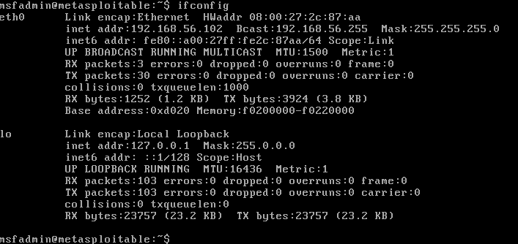

Step 2: Accessing the Web Application
Using a web browser on the attacker machine (Kali Linux), the Damn Vulnerable Web App was accessed at http://192.168.56.102/dvwa/login.php. The login page loaded successfully, confirming the web server was operational.
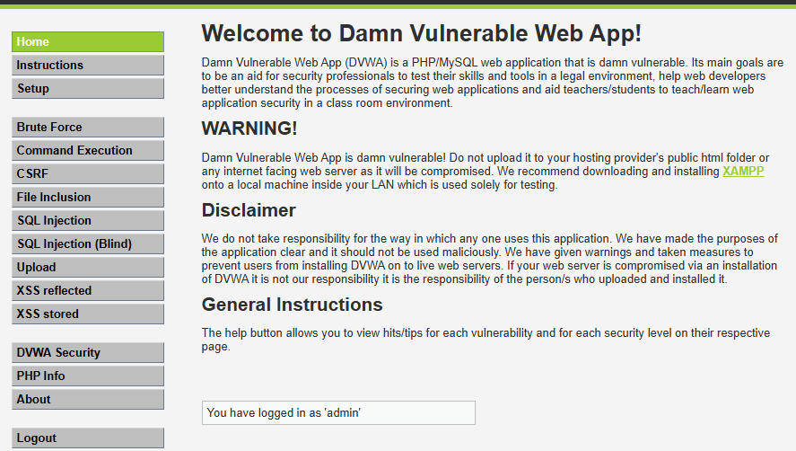
Step 3: Navigating to the XSS Reflected Page
From the main menu, the "XSS reflected" option was selected. This page accepts user input through a text field labeled "What's your name?" and reflects the input back to the browser without any filtering or encoding.
Step 4: Payload Injection
A standard XSS proof-of-concept payload was entered into the input field. The payload used was:
<script>alert(1)</script>

Step 5: Vulnerability Confirmation
After submitting the payload, the application responded by displaying "Hello" followed by the injected script. Instead of treating the script as plain text, the browser interpreted it as executable JavaScript code. As a result, an alert dialog box appeared on the screen displaying the number "1".
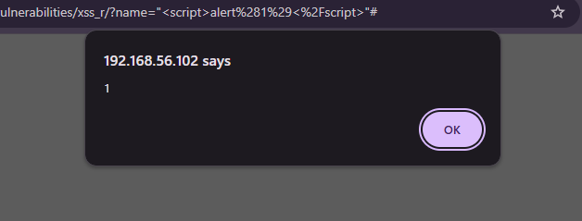Remediation Recommendations
- Output Encoding – Use `htmlspecialchars()` to convert `<` into `&lt;` and `>` into `&gt;`
- Input Validation – Allowlist only safe characters (letters, numbers), reject everything else
- Content Security Policy (CSP) – Add `Content-Security-Policy: script-src 'self'` header to block inline scripts
- HttpOnly Cookie Flag – Set `HttpOnly` attribute on session cookies to prevent JavaScript access
- X-XSS-Protection Header – Add `X-XSS-Protection: 1; mode=block` for browser-based filtering
- Regular Security Testing – Perform routine XSS scans using tools like OWASP ZAP or Burp Suite

